Bahria University,

Karachi Campus



LAB EXPERIMENT NO.

**5**

LIST OF TASKS

|  |  |
| --- | --- |
| TASK NO | OBJECTIVE |
| **1** | Design and implement an ASP.NET Core Web API with endpoints for GET (retrieve products), POST (add products), PUT (update products), and DELETE (remove products) methods to manage a product inventory system. |
| 2 | Create an ASP.NET Core Web API for managing student records, enabling CRUD operations (GET, POST, PUT, and DELETE) for adding, retrieving, updating, and deleting student information. |

Submitted On:

4 April 2024

____________

(Date: DD/MM/YY)

**Task 1**

Design and implement an ASP.NET Core Web API with endpoints for GET (retrieve products), POST (add products), PUT (update products), and DELETE (remove products) methods to manage a product inventory system.

**Product Model:**

namespace CCLab5.Models

{

public class Product

{

public long Id { get; set; }

public string Name { get; set; }

public int Price { get; set; }

public int Quantity { get; set; }

public string Description { get; set; }

}

}

**Product Context:**

public class ProductContext : DbContext

{

public ProductContext(DbContextOptions<ProductContext> options) : base(options) { }

public DbSet<Product> Products { get; set; } = null;

}

**Program Class:**

builder.Services.AddDbContext<ProductContext>(opt => opt.UseInMemoryDatabase("Product"));

**Products Controller:**

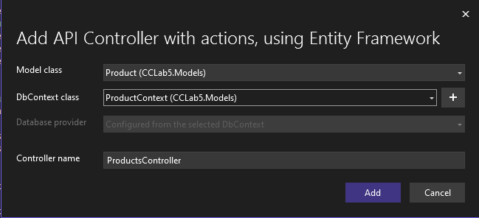

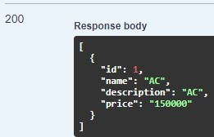

**Task 2**

Create an ASP.NET Core Web API for managing student records, enabling CRUD operations (GET, POST, PUT, and DELETE) for adding, retrieving, updating, and deleting student information.

**Student Model:**

public class Student

{

public int Id { get; set; }

public string Name { get; set; }

public string Enroll { get; set; }

public string Department { get; set; }

public int Semester { get; set; }

public string Batch { get; set; }

}

**Student Context:**

public class StudentContext:DbContext

{

public StudentContext(DbContextOptions<StudentContext> options) : base(options) { }

public DbSet<Student> Students { get; set; }

}

**Program Class:**

builder.Services.AddDbContext<StudentContext>(opt => opt.UseInMemoryDatabase("Student"));

**Students Controller:**

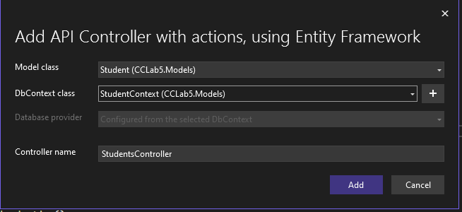

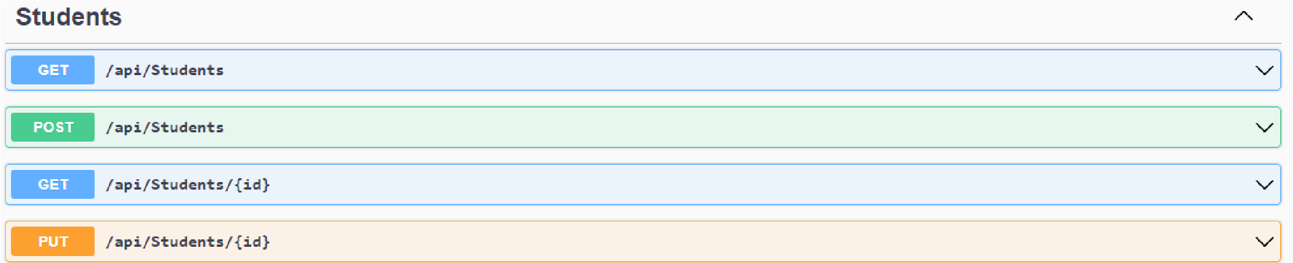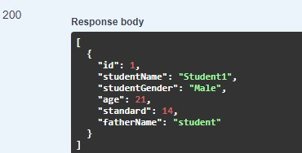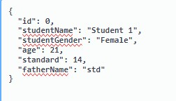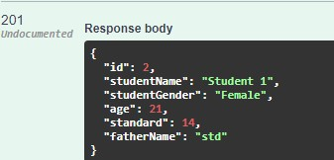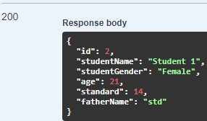

**Post**

**Request Response**

**Get Request**

**api/Students**

**/2**

